aerospace department task

# Design specifications

***All the formulas that are not specified in this report can be found on the Matlab code.***

This year, we are participating in the IMechE Unmanned Aerial System (UAS) Challenge. The Unmanned Aircraft (UA) will be designed to carry out a humanitarian aid mission. The system will be required to perform tasks such as take-off and landing, navigating through waypoints and gates, dropping the Aid Package, and returning to base via a designated route.

Consider an UA with fixed wing. The competition imposes to have a maximum total weight of 10 kg, where the payload weighs at least 1.25 kg. We can consider a structural mass that is approximately the 35-50% of the maximum weight. The takeoff needs to be completed in a 10x10 m area.

1: You have to choose the motors, how many and the relative batteries to allow a flight of at least 15 minutes (after landing their remaining capacity should be 20%), considering that the objective is to have the heaviest payload possible, and the maximum speed is EAS = 50 kts.

2: It’s requested to estimate the CG position with and without the payload, considering the stability problems and that high maneuverability is requested.

3: Calculate the surface of the wing (S) and its length (b), the drone inertia tensor (I), the stability margin (sm).

4: How to design flaps to facilitate takeoff within 10 meters? Write down an essential analysis focusing on the trade-off between aerodynamics and aircraft lightweight and reliability.

5: Select an airfoil and discuss the reason. You can avoid this point using NACA0012, airfoil tables can be easily found on the internet.

# Weight Estimation

* **Maximum Total Weight (MaxW):** 10 kg.
* **Minimum Payload Weight:** 1.25 kg (Parameter to be maximised).
* **Structural Mass:** 35–50% of MaxW, which ranges from 3.5 kg to **5.0 kg**.

The remaining mass would be allocated to the propulsion system (motors, batteries) and the remaining systems (control, electronics, etc.), along with the extra payload weight we can carry.

As this is a conceptual design, I will assume the worse case scenario, which is an airframe accounting for 50% of the MaxW, the remaining 3.75 kg will include the motors, batteries, and other electronic systems like servos, controllers, which I will try to minimize to get a better payload capability.

# takeoff calculations

I selected 5 motors from the provided websites to calculate the lightest overall configuration, all of them have been chosen with the most efficient propeller configuration. We will use a single motor configuration for weight saving and to reduce complexity.

The selected motors are:

1. (AT3530 Long Shaft KV 580, n.d.)
2. (AT 3520 Long Shaft KV550, n.d.)
3. (AT 3520 Long Shaft KV720, n.d.)
4. (AT3520 Long Shaft KV850, n.d.)
5. (AT2826 Long Shaft KV900, n.d.)

I then used the max thrust of each motor to calculate the maximum acceleration the motor can give the plane in the 10m “runway”.

**Assumptions:**

* We cannot take off diagonally in the 10x10 area, so the runway length can’t be 14.14m.
* The takeoff area is concrete/asphalt, so negligible drag.
* Aerodynamic drag is negligible due to the low take off speed.
* 0.9 as a safety margin for final speed achieved.
* The UAV weighs 10 kg.

We can simply calculate the acceleration with $a=\frac{T}{m}$ and from here the time it takes to do the 10 meters $t= \sqrt{\frac{2*l}{a}}$ and the velocity at the end of the runway $v_{f}=a*t$.



# wing design based on take off calculations

I will use the provided NACA0012 airfoil since it’s a symmetric airfoil which can reduce overall cost and it’s easier to manufacture, while still providing good performance characteristics in low-speed flight. We can calculate the Reynold number using (Reynolds calcualtor, n.d.) and get a value over 350.000, so I’ll use the 200.000 data to be conservative.

To minimize drag, I will design the wing trying to maximize the efficiency while keeping a realistic Aspect Ratio (AR) of the wing that can provide a good structural integrity of the wing along with realistic dimensions of the UAV, so I will limit the wingspan to 5m and the aspect ratio to 20 (typical value for gliders). I will also assume a realistic geometry that will give the plane good maneuverability while still maintaining stability, so I’ll be aiming at a stability margin (sm) of around 0.10.

With this kind of mission it is immediately apparent that a flaps system will bring the correct way to go, the only drawbacks are a bit more complexity added to the system and very little more weight added from the servo mechanism, while the pros are a much smaller wing surface area that will bring less weight in the structure of the plane and also less drag during flight, which will allow for a lighter battery.

**Assumptions:**

* Position of the center of gravity (xg) = 0.52m.
* Position of the center of lift (xn) = 0.55m.
* Position of the center of lift of the tail (xlc) = 2.5m.
* $C_{L,flaps}$ is around 1.6, from the polar equation of the wing max $C_{L}$ = 1.1 before stall. (Polar eq, n.d.)
* **Wingspan (b) = 5m** to maximize AR.

We can calculate the wing surface area of the wing with this formula with the equilibrium of moments:

Table 1: AR, S and Vf of the 5 configurations

From the table we can see that with a maximum wingspan of 5 meters all the configurations are within the limit aspect ratio assumed.

We can now calculate the wing cord and the **stability margin** of the 5 configurations:



We can observe that with this geometry all the configurations are stable, with config 5 being the less stable with a stability margin around 6.67%, still within the acceptable values with payload (that will make the plane less stable, being it positioned a few cm behind the center of lift.

# motor and battery configuration

I will assume the cruise speed to be a value between 40 kts to the maximum allowed speed of 50 kts and select the most efficient configuration.

Using the polar equation of the wing I can now get the coefficient of lift CL for cruise speeds between 40 and 50 kts and the relative drag coefficient CD along with the induced drag coefficient CDi of a 3D wing and the drag coefficient of the plane’s body, assumed to be 0.03 (drag estimation of short-to-medium range fixed-wing UAVs, n.d.). We can then see the efficiency of the wings and required thrust plotting the data with matlab:

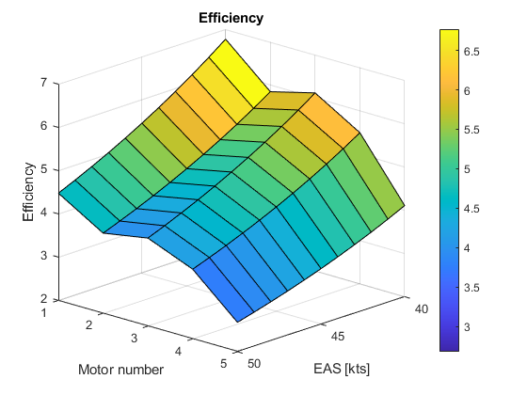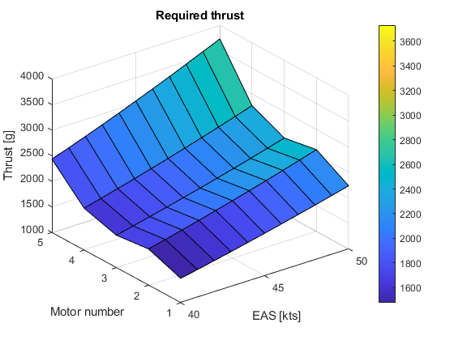

Using the engine data from Tmotor we can then calculate the power consumption of each configuration.

The energy will be calculated for a 15-minute flight at cruise speed with and added 20 seconds of max power assumed for takeoff and climb. The resulting energy will then be divided by 0.8 in order to get a 20% residual battery capacity at the end of the mission.

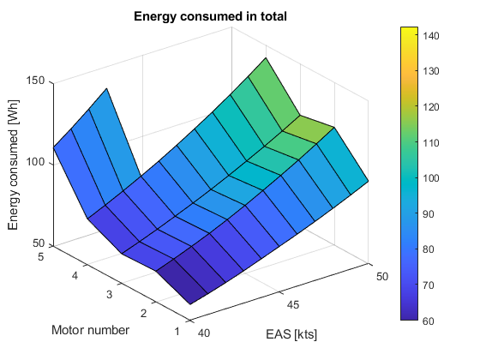From this graph we can see that engine 5 cannot reach the maximum speed allowed and is very inefficient, so we will exclude it from now on. We can also see that the most efficient cruise configuration with the wing design obtained by the takeoff parameters is the minimum assumed of 40 kts.

We can finally calculate the weight of each configuration of engine + batteries:



List of batteries:

1. (6s 22.2V 3500 mAh, n.d.)
2. (6s 22.2V 4000 mAh, n.d.)
3. (5s 18.5V 5500 mAh, n.d.)
4. (4s 15.2V 6500 mAh, n.d.)

As we can see the lightest configuration assuming equal weight for all the structures is the configuration number 5, which is not the most energy efficient. This is since 15V batteries have less cells than the higher voltage ones and have consequently an overall lower weight than the counterparts.

# inertia tensor calculation

To calculate the inertia of the plane I used a simplified model with a full cylinder as the fuselage and tail section and two beams as the wings.

**Assumptions:**

* Mass of the fuselage + tail = 8 kg.
* Mass of the wings = 2 kg.
* Radius of the fuselage = 0.2 m.
* Length of the fuselage = 2.5m
* Wingspan (b) = 5 m.

From this data we can get an inertia tensor of $I= \left[\begin{matrix}4.3267 & 0 & 0 \\ 0 & 4.2467 & 0 \\ 0 & 0 & 8.4133\end{matrix}\right] kg*m^{2}$.

# final configuration

From my analysis the best configurations appear to be the number 4 flying at a cruise speed of 40 kts.

* **Motor:** 1x (AT3520 Long Shaft KV850, n.d.).
* **Battery:** 1x (4s 15.2V 6500 mAh, n.d.).
* **Xg:** 0.52 m.
* **Wing surface (S):** 1.6595 $m^{2}$.
* **Wingspan (b):** 5 m.
* **Inertia tensor: $I= \left[\begin{matrix}4.3267 & 0 & 0 \\ 0 & 4.2467 & 0 \\ 0 & 0 & 8.4133\end{matrix}\right] kg*m^{2}$** .
* **Stability margin (sm)**: 9.04%.
* **Flaps**: flaps with a $C_{L,flaps}$ = 1.6.
* **NACA0012** airfoil.

# Riferimenti

(s.d.). Tratto da drag estimation of short-to-medium range fixed-wing UAVs: https://link.springer.com/article/10.1007/s13272-021-00522-w

*4s 15.2V 6500 mAh*. (s.d.). Tratto da https://www.gaoneng.shop/products/gaoneng-gnb-hv-4s-15.2v-6500mah-70c-t-plug-lipo-battery

*5s 18.5V 5500 mAh*. (s.d.). Tratto da https://www.gaoneng.shop/products/gaoneng-gnb-5s-18.5v-5500mah-70c-xt60-lipo-battery

*6s 22.2V 3500 mAh*. (s.d.). Tratto da https://www.gaoneng.shop/products/gaoneng-gnb-6s-22.2v-3500mah-70c-lipo-battery-t-plug

*6s 22.2V 4000 mAh*. (s.d.). Tratto da https://www.gaoneng.shop/products/gaoneng-gnb-6s-22.2v-4000mah-70c-lipo-battery-t-plug

*AT 3520 Long Shaft KV550*. (s.d.). Tratto da https://store.tmotor.com/product/at3520-long-shaft-fixed-wing-motor.html

*AT 3520 Long Shaft KV720*. (s.d.). Tratto da https://store.tmotor.com/product/at3520-long-shaft-fixed-wing-motor.html

*AT2826 Long Shaft KV900*. (s.d.). Tratto da https://store.tmotor.com/product/at2826-long-shaft-fixed-wing-motor.html

*AT3520 Long Shaft KV850*. (s.d.). Tratto da https://store.tmotor.com/product/at3520-long-shaft-fixed-wing-motor.html

*AT3530 Long Shaft KV 580*. (s.d.). Tratto da https://store.tmotor.com/product/at3530-long-shaft-fixed-wing-motor.html

*Polar eq*. (s.d.). Tratto da http://airfoiltools.com/polar/details?polar=xf-n0012-il-200000

*Reynolds calcualtor*. (s.d.). Tratto da https://aerotoolbox.com/reynolds-number-calculator/